**Step 1: Use Analog Devices Filter Wizard to design the plant**

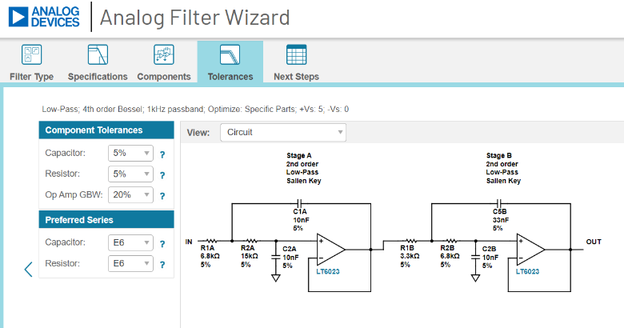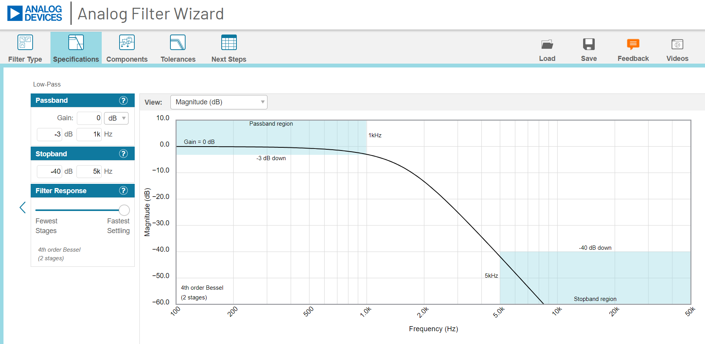

**Step: Use Excel to convert the component values into the transfer function for each section.**

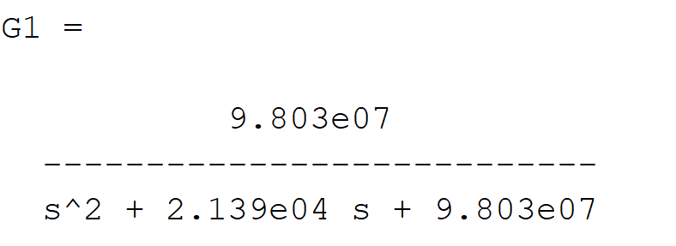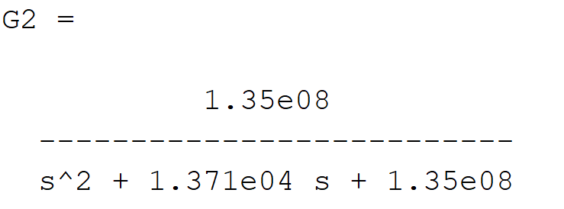

**Step 3: Use Matlab to examine the open-loop behavior**

margin(G1*G2) nyquist(G1*G2)

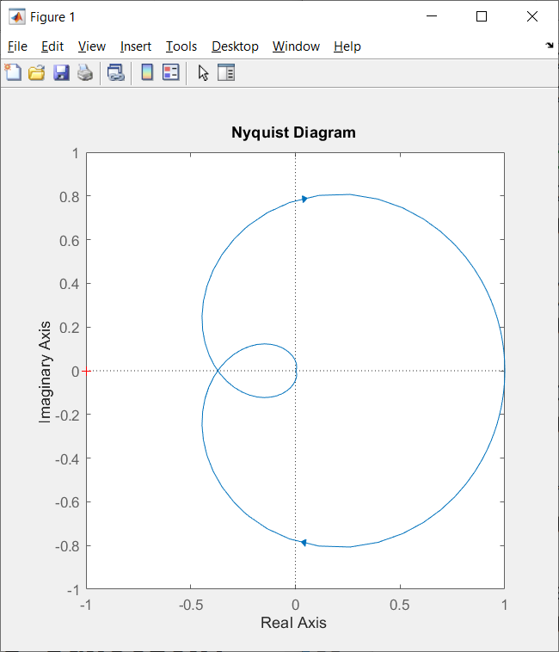

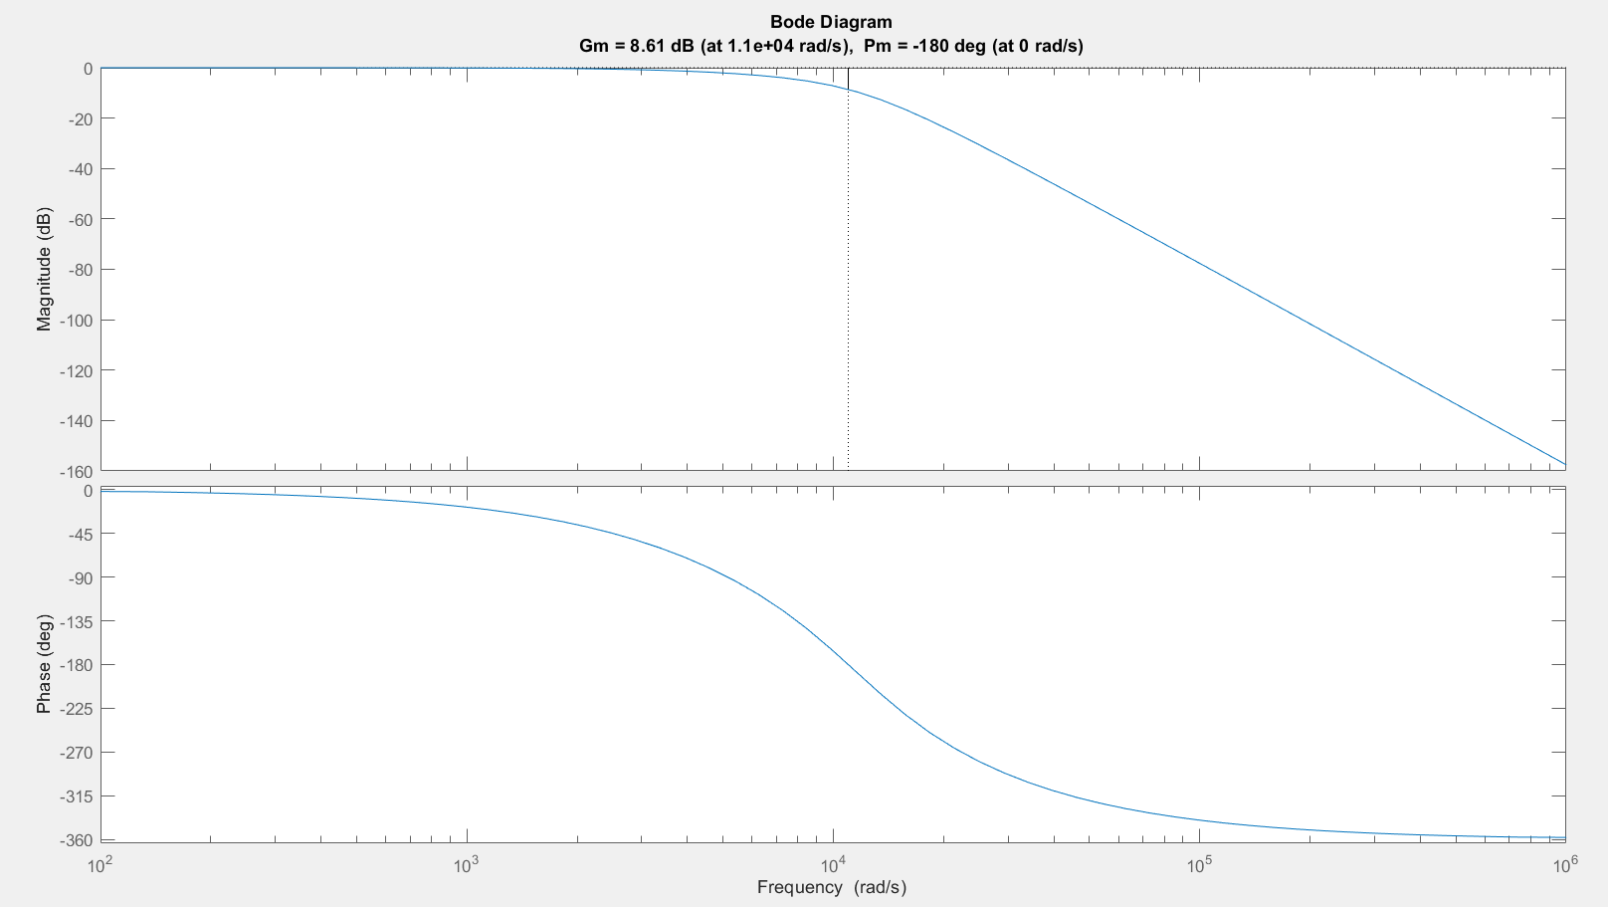

With a gain margin, we can scale G1*G2 by 10^(8.61/20) = 2.7

before the closed loop goes unstable.

**Step 4: Use ModelSim to examine the closed loop behavior.**

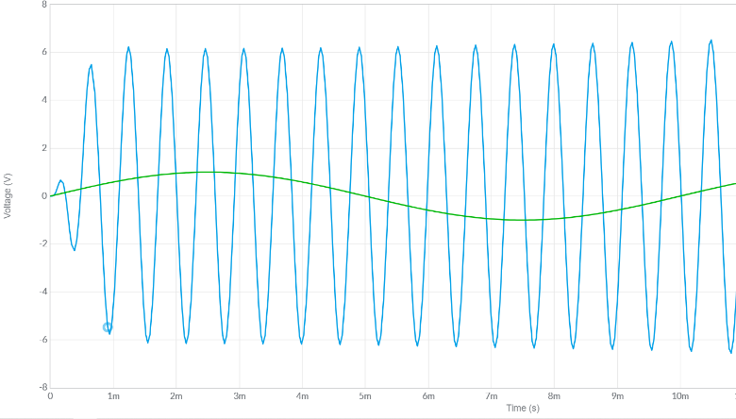

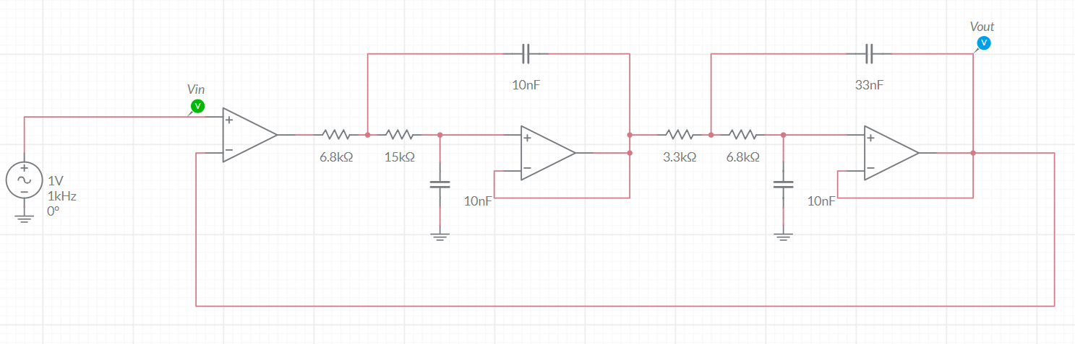

**Step 5: Check that this is not a problem with the simulator.**

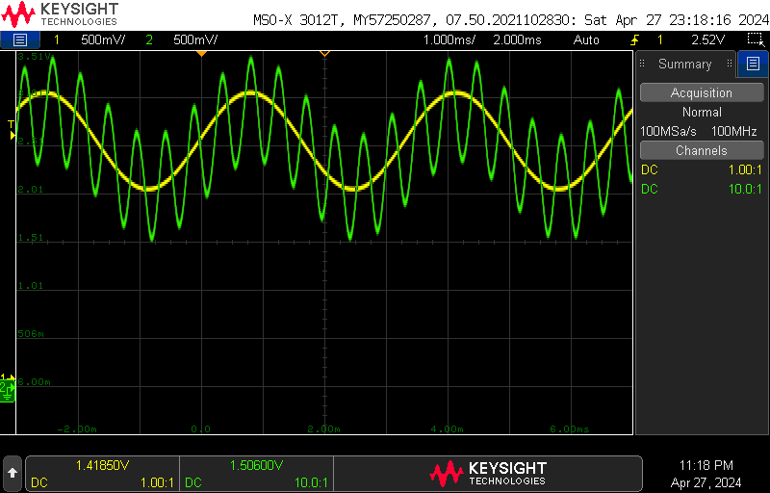

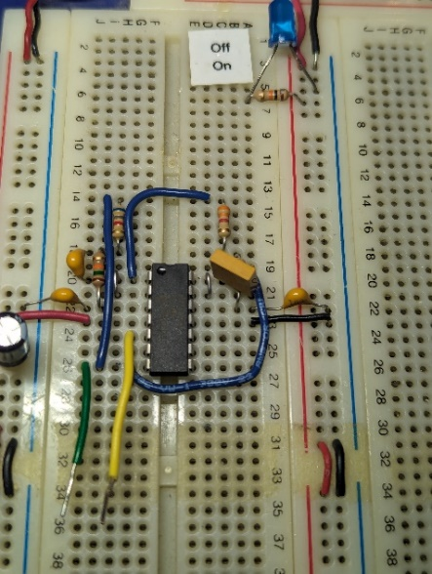

**Step 6: Hypothesize, research, explain.**

